DAD 220 Module Five Activity Template

Complete these steps as you work through the directions for this activity. Refer to the guidelines and rubric for help with how to complete these steps. Rename this template by adding your last name to the file name. Replace the bracketed text in the template with your responses and supporting screenshots as you complete the activity. Size each screenshot and its explanation to fit approximately one-quarter of the page. Review the Template Screenshot Example linked in the guidelines and rubric for this assignment to see how screenshots for your assignment should look. Submit the completed template for grading and feedback.

- Analyze the data provided in FleetMaintenanceRecords to identify themes.
  - Review part-replacement frequencies and types. Then create a hypothesis that the fleet management team can use to better handle maintenance.
    - Create a table called Parts Maintenance. Put this table in the database named after yourself.
    - Load the data set from the ‘/home/codio/workspace’ path and run queries to find the results. You should use the following line terminators when importing: \n.
    - Answer the following questions and provide supporting screenshots.
      - Which parts are being replaced most often?

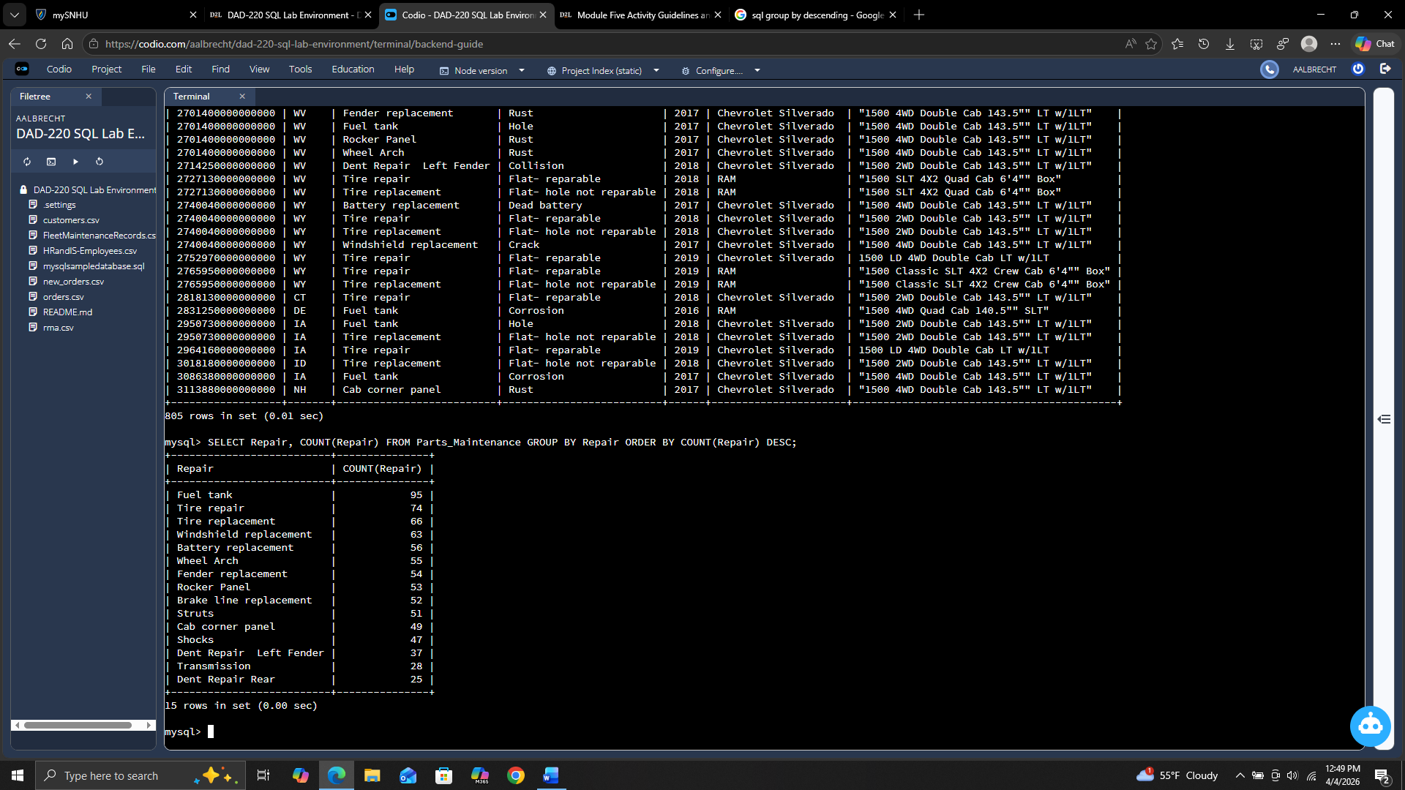

The most replaced item is the fuel tank followed by tire repair and tire replacement.

      - Which region or regions of the country experience more part failures and replacements than others?
        - Identify the region or regions with more reasons for the replacement of parts.
        - Use the Region Definitions sheet to identify states in each region.

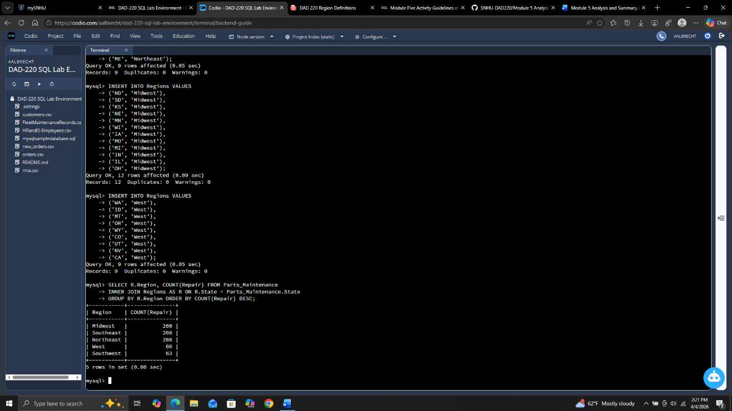

The midwest has the most repairs followed by both northeast and southeast regions.

      - How might the fleet maintenance team use the information to update its maintenance schedule?
The fleet maintenance can use this information to increase the number of technicians available for repair in the higher regions and also increase the number of spare parts in stock to make sure they can adequately handle the number of repairs without big delays for ordering parts.

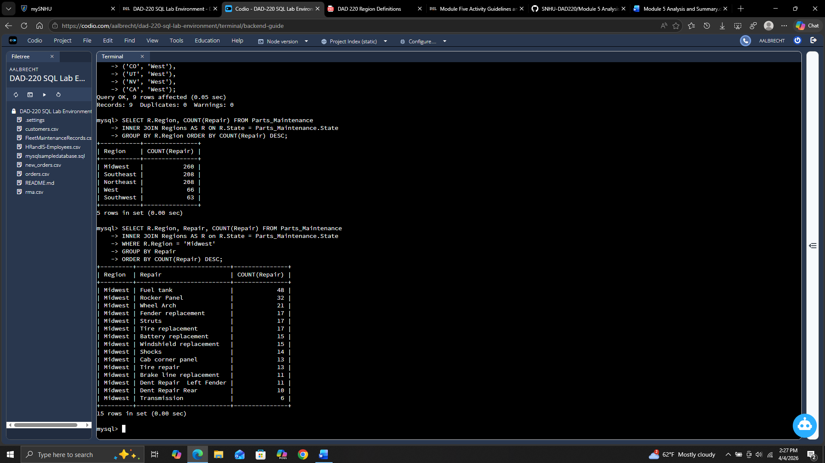

      - Which parts are being replaced most often due to corrosion or rust?

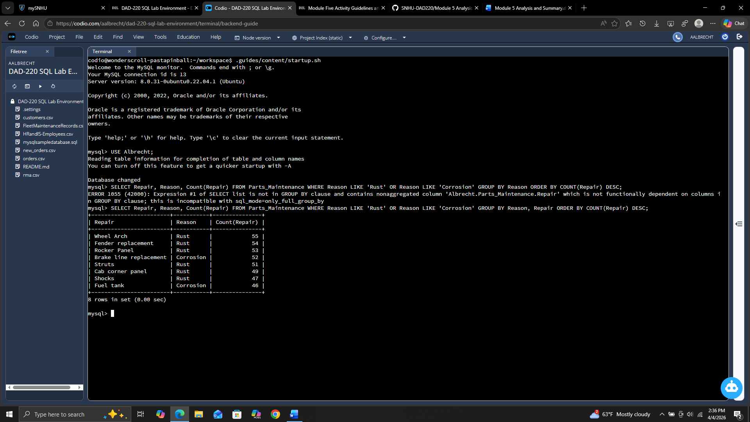

Wheel arch, fender replacement, and rocker panel are the 3 most repaired items due to rust/corrosion.

      - Which parts are being replaced most often because of mechanical failure or an accident like a flat tire or rock through the windshield?

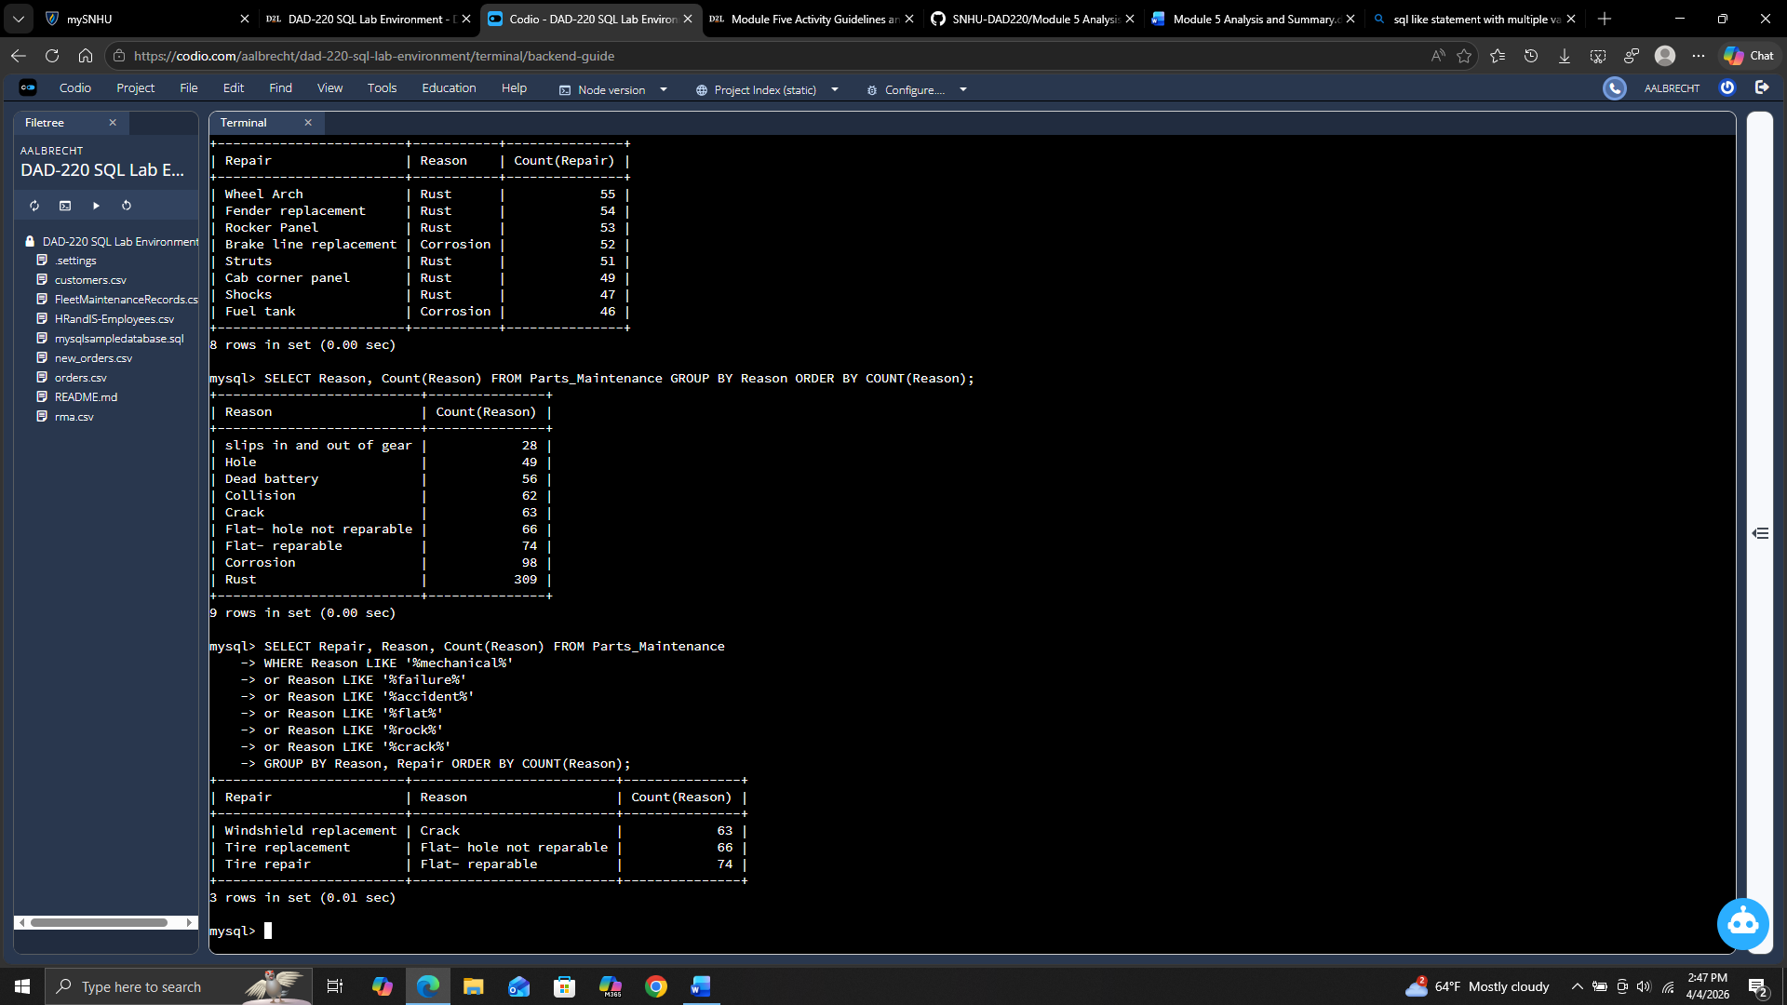

The most common things replaced are tires and windshields.

- Write a brief summary of your analysis that takes the information from step one and presents it in a way that nontechnical stakeholders can understand. Write your response in paragraph form.

Based on the analysis of this data, the midwest, northeast, and southeast regions have almost 3.5 to 4 times the repairs than the southwest or the west regions. Across all regions the fuel tanks and tires are the most repaired/replaced parts. Knowing this information, increasing staff and inventory to accommodate these findings should allow us to be more efficient. By increasing efficiency, our customer satisfaction should also increase as we will be able to handle the repairs faster and with fewer delays.

- Outline the approach that you took to conduct the analysis.
  - What queries did you use to identify trends or themes in the data?

I first created a Regions table that had each of the states and the corresponding region. This allowed me to simply join that table with the parts_maintenance table making the queries easier to execute and involving less code. Many of the queries used the COUNT aggregation to add up how many of either a particular region or repair was reported. Several queries also used the WHERE clause to narrow data or the GROUP BY and ORDER BY to organize the data.

  - What are the benefits of using these queries to retrieve the information in a way that allows you to provide valuable information to your stakeholders?

By using these queries, I was able to see where most of the repairs are located and what type of repairs they were. Gathering this information will allow the stakeholders to make the decisions to needed to adjust the business so that it can be more efficient and able to handle the needs of their customers.

- Explain how the functions in the analysis tool (MySQL) allowed you to organize the data and retrieve records quickly.

I used the COUNT aggregate function to get the number of how many of each type of repair that happened. I also used the WHERE clause to filter the data to what I was looking for. The GROUP BY and ORDER BY organized the data so it was easier to read. I also used an INNER JOIN to join the Regions table I created so I wouldn’t have to keep adding in the region details to each search.

